set 2-- Additional applications of free-electron models

2.1. Boundary conditions revisited.

For the 1D problem we discussed the situation where the particle is confined within a length of L. We require that the wavefunction vanishes at the two ends.
We calculated that the eigenstates are $ϕ_{n}=\sqrt{\frac{2}{L}}\text{sin}(\frac{nπx}{L})$ or the allowed $k={nπ}/L\text{.}$
Here n=1,2,3,….

We can also impose the so-called periodic boundary condition where we require that the wavefunction and its derivative be identical at x=0 and x=L. This is equivalent to having a circular ring.
If the potential is zero the two independent solutions are $e^{±\text{ikx}}$. Clearly the periodic condition is satisfied if $\text{kL}=2πn$. The allowed n's here are $n=0,±1,±2,\text{.}\text{.}\text{.}\text{.}\text{.}$

Which boundary conditions we want to use depend on the physical problem. With the periodic boundary condition it is equivalent to neglecting the surface effect.

Let us consider the following applications.

2.2. Free electrons in 3D (or free electron gas in 3D)

If the electrons are confined in a box of dimension L_{x}, L_{y} and L_{z}, using the periodic boundary condition the wavefunction can be written as
$Ψ(x,y,z)=(L_{x}L_{y}L_{z})^{{−1}/2}\text{exp}(i\vec{k}⋅\vec{r})$
where $k_{x}L_{x}=2{πn}_{x}$, $k_{y}L_{y}=2{πn}_{y}$, $k_{z}L_{z}=2{πn}_{z}$. The unit volume in the k-space is $(2π{)^{3}}/V\text{.}$ For the volume V, if the total number of electrons is N, the maximum k, or called k_{F}, that the electrons can occupy is

$N=2(V/8π^{3})(\frac{4}{3}{πk}_{F}^{3})$
where the prefactor 2 on the right is due to the two spin states for each k, and the Fermi energy is $E_{F}=ℏ^{2}{k_{F}^{2}}/2m$.
In the ground state, all the electrons occupy the k-space below k_{F}, or in the energy domain, all the electrons are filled up to the Fermi energy.

Density of states (DOS): Number of electrons per unit energy per unit volume.
This is a very important concept. For the 3D electron gas, one can calculate

$n(ε)=\frac{1}{2π^{2}}(\frac{2m}{ℏ^{2}})^{3/2}\sqrt{ε}$

We next generalize the concept to 2D and 1D systems. For the quantum slabs, assuming that L_{z} is much smaller in dimension so in the z-direction we will assume that the wavefunction vanishes at z=0 and L_{z}, while the periodic boundary conditions are applied in the other two directions. Clearly the energies is given by

$E_{\vec{k}}=\frac{ℏ^{2}π^{2}}{2{\text{mL}}_{z}^{2}}n^{2}+\frac{ℏ^{2}}{2m}(k_{x}^{2}+k_{y}^{2})$

Since L_{z} is much smaller, the spectrum separates into bands for different n. The electrons will be filled from the first band before it starts filling the second band, ..etc. From the exercise 2-2 below. You can calculate the density of states.
One can generalize this approach to Quantum wires (1D) and Quantum Dots (0D). The density of states are shown in this figure:

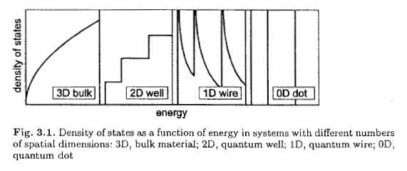
2.3. "Spherical" coordinates in 2D and 3D -see homework
Review the separation of variables--see any textbook

--------------------------------------------------------------------------
Homework 2. (these problems are from Harrison)
2-1. For a box of length L on each side containing N electrons, calculate $k_{F}$and $E_{F}$using the boundary condition that the wavefunction vanishes on the face of the box. Compare your results with those obtained using the periodic boundary condition.

2-2. Review the 2D Schrodinger equation in polar coordinates and the 3D equation in spherical coordinates. Assume that the potential depends only on the radial distance and using separation of variables, write down the ordinary differential equations satisfied by each coordinate, and the analytical solutions for the angular functions. (You can just look up or work it out.)

2-3. The next three problems are from Harrison.
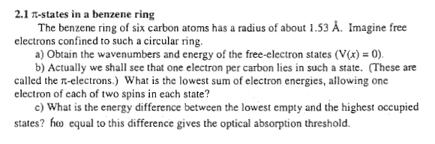
2-4.
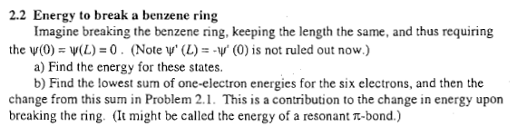

2-5. (use periodic boundary condition) 